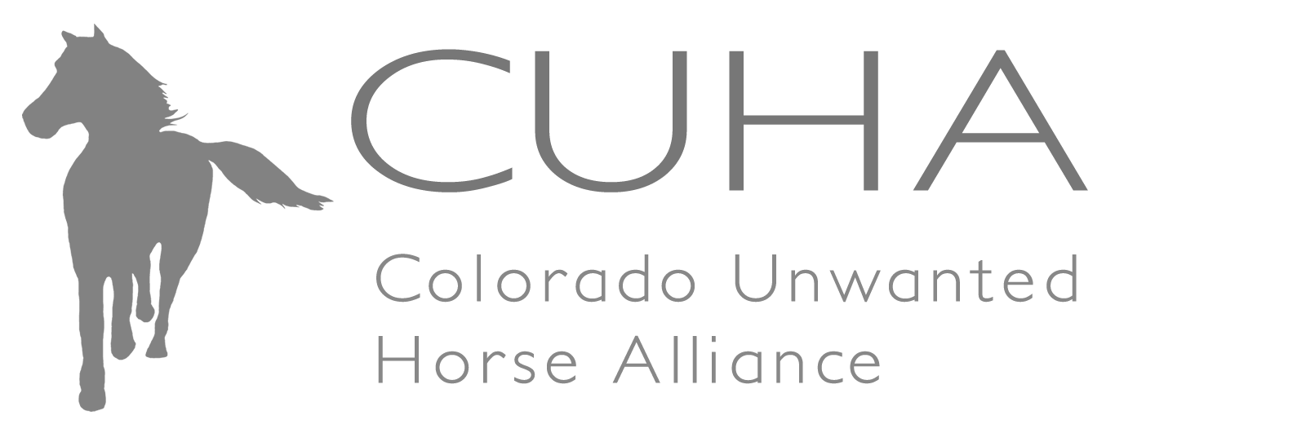

2024 Supplemental Grant Opportunity: Guidelines and Application Form

This grant is presented as a supplemental opportunity to CUHA’s annual grant cycle. This is a reimbursement grant, and monies will be delivered after invoices are submitted and received.

The deadline for this supplement grant application is March 3, 2025.

Please note: CUHA has created an At-Risk Fund in which grant requests can be made at any time during the year for specific requests, including emergency hay grants, end of life/euthanasia, gelding, farrier services (not routine maintenance care of feet) and emergency medical care including teeth floating (not routine maintenance care of teeth), laceration repair, de-wormer or other emergency medical intervention for horses at risk of becoming unwanted. Please make use of the At-Risk Fund for more immediate needs throughout the year in addition to this annual grant application below. The below guidelines have been updated so please read carefully.

The mission of the Colorado Unwanted Horse Alliance (CUHA) is to reduce the number of unwanted horses in Colorado, and to promote public and private collaboration and education concerning their welfare, ownership and disposition. The Alliance, a 501(c)(3) not-for-profit corporation that partners with data collection organizations regarding the number and status of Colorado’s unwanted horses, provides information concerning the purchase, care and disposition of horses, and assists and supports federal, state and local organizations engaged in the same or similar work.

The Alliance provides funding to programs for horses that are unwanted or at-risk of becoming unwanted. CUHA is seeking proposals for programs that address the following (the order listed below is not ranked in order of importance):

- Training Programs that increase the adoptability of rescued horses that are untrained, not started under saddle, or have behavioral problems, but are otherwise adoptable. Preference will be given to trainers working with horse rescues.
- Standard care for horses in training ($500 maximum), includes farrier care, veterinary care, de-worming, feed, and other general care.
- Gelding Programs from veterinarians, horse rescues and other organizations that assist horse owners to geld horses, thereby addressing horse overpopulation and management.
- End of Life Programs that offer humane euthanasia options, or training on best practices for carrying out humane euthanasia.
- Educational Outreach Programs that address any of the above issues, and help communities work collaboratively to solve local problems and educate individuals about ownership, care, and feeding.
Other such as a creative program or project intended to help sustain your work and/or increase your efficiency or effectiveness so that your work can continue for the long term. Also, veterinary expenses and hay grants are excluded from this category, as they are addressed by “At Risk” funds.

The application should propose a program compatible with one or more of the above areas of focus. Parties with ideas for other requests not covered in the six points above are encouraged to contact CUHA via email at info@counwantedhorse.org for discussion. Preference will be given to proposals that will have a high impact for addressing the number of at-risk/unwanted horses in Colorado or to programs that will directly or indirectly decrease the number of horses that become at-risk/unwanted each year.

Organizations eligible to apply include 501(c)(3) not-for-profit organizations, governmental agencies with statutory authority, Colorado tax exempt corporations, and private businesses (for example veterinarians, horse trainers, farriers) demonstrating substantial charitable effort toward Colorado’s at-risk/unwanted horses. Organizations that do not currently meet these eligibility criteria should contact the Alliance prior to applying.

In order to apply please:

E-mail an electronic copy of your application form with attachments to info@counwantedhorse.org by March 3, 2025. Incomplete applications will not be funded. This includes failure to provide end of year data. Please review section 6 as there are no exceptions.

If you have any questions about the application process, please do not hesitate to email info@counwantedhorse.org.

Section 1: Facility Information

Legal Name of Organization:

DBA (if applicable):

Mailing Address, City, State, and Zip:

Physical Address (if different from Mailing Address):

Phone: EIN:

Website:

Name of Authorized Representative:

(CEO, Executive Director, Owner, Specialist)

Phone: Email:

Mission Statement/Statement of Purpose:

Geographic Area Served (specific to this proposal):

Year Founded:

Type of Organization:

 501(c)(3) Organization  Government Agency  Private Business
 Colorado Tax Exempt Corporation  Other
Describe:

Number of Employees: Full-time: Part-time:

Number of Volunteers: Full-time: Part-time:

Have you ever applied for a CUHA grant? Yes/No

By signing below, I certify that the information contained in this application is true and correct to the best of my knowledge.

Authorized Representative: Date:

Please continue to next section.
Section 2 Questionnaire

  - Amount of Request:

  - Describe the program(s) for which you are requesting funding and the impact it will have on at-risk/unwanted horses in your area. Please be specific about the number of horses you will be able to help and specifically the cost per horse to do so.

- Identify the community partners with whom you will collaborate and who can provide references for your program, please list contact information for the partners identified:

- List the major funders of your organization over the past two years:

Section 3 Application Attachments

501(c)(3) Organizations and Colorado Tax Exempt Corporations must provide the following attachments:

Please check all boxes below as you enclose each required item:
□ Copy of 501(c)(3) determination letter (if applicable)
□ Certificate of Good Standing with the State of Colorado as a not-for-profit organization
□ Letter of reference from your veterinarian if you are an equine facility
□ List of your Board of Directors or other organizational leadership – bios are NOT required
□ Financial statements shall include current income and expense statements, balance sheet, and most recent complete form 990.
□ Project budget
□ Promotional material used to promote horse programs if available (can be sent via regular mail)
□ Story of one of the horses helped from your previous grant
□ A copy of the Equine Welfare Data Collective Certificate

Government Agencies must provide the following attachments:

Please check all boxes below as you enclose each required item:
□ Letter of reference from your veterinarian if you are impounding horses
□ Project budget
□ Promotional material used to promote horse programs if available, (can be sent via regular mail).
□ Story of one of the horses helped from your previous grant
□ A copy of the Equine Welfare Data Collective Certificate

Private Businesses must provide the following attachments:

Please check all boxes below as you enclose each required item:
□ Copy of current Colorado State license or accreditation/certification (e.g. veterinary license)
□ Project budget
□ Promotional material used to promote horse programs if available (can be sent via regular mail).

Section 4: Historical Data (this section should only be completed by horse rescues/sanctuaries)

To the best of your ability and to the extent that you have any of the following information available: Please provide the historical data requested below for the years 2021, 2022, and 2023. If you have data for additional years please also provide that where possible. Please complete these data even if you have supplied it previously.

Please indicate the number of horses impacted specifically during the calendar year January 1 to December 31.
Dates:

 | Horse Rescue Capacity | # Horses surrendered  by owner | # Horses  received from law enforcement | # Horses  Adopted | # Horses  Euthanized | Approximate # horses rescue declined/  unable to take
2021
2022
2023

Number of rescue horses currently at your rescue facility:

*Horses received from other sources:
 | # Brand Inspector | # Purchased at Sale | # Abandoned | # Returned | # Other
2021
2022
2023

Please continue to next section.

Section 5: End of Year Grant Report

If you’ve received previous funding from CUHA, please indicate the following:

1) Type of program money was awarded for.
2) Amount of funding not spent:
3) The specific the number of adoptions that were directly affected by the funds granted by CUHA.
4) Examples of how your organization has promoted or acknowledged grant funding from CUHA.

Section 6 - Submission Process and Deadline

      - Submit a single PDF file of the application and attachments to info@counwantedhorse.org. Electronic copy must be received no later than March 3, 2025.
      - Please ensure all attachments are included with your electronic copy. Promotional items may also be sent via regular mail.
      - Faxed proposals will not be accepted.
      - Incomplete applications will not be accepted.
      - End of year report for previous year must be completed and attached.
      - Failure to submit all items will nullify your grant application.

It is our practice to acknowledge proposals within five business days of receipt via e-mail. If you do not receive an acknowledgement or want to confirm delivery, please email info@counwantedhorse.org.

